**Difference between JPA, Hibernate and Spring Data JPA**   
  
Java Persistence API (JPA)

* JSR 338 Specification for persisting, reading and managing data from Java objects
* Does not contain concrete implementation of the specification
* Hibernate is one of the implementation of JPA

Hibernate

* ORM Tool that implements JPA

Spring Data JPA

* Does not have JPA implementation, but reduces boiler plate code
* This is another level of abstraction over JPA implementation provider like Hibernate
* Manages transactions

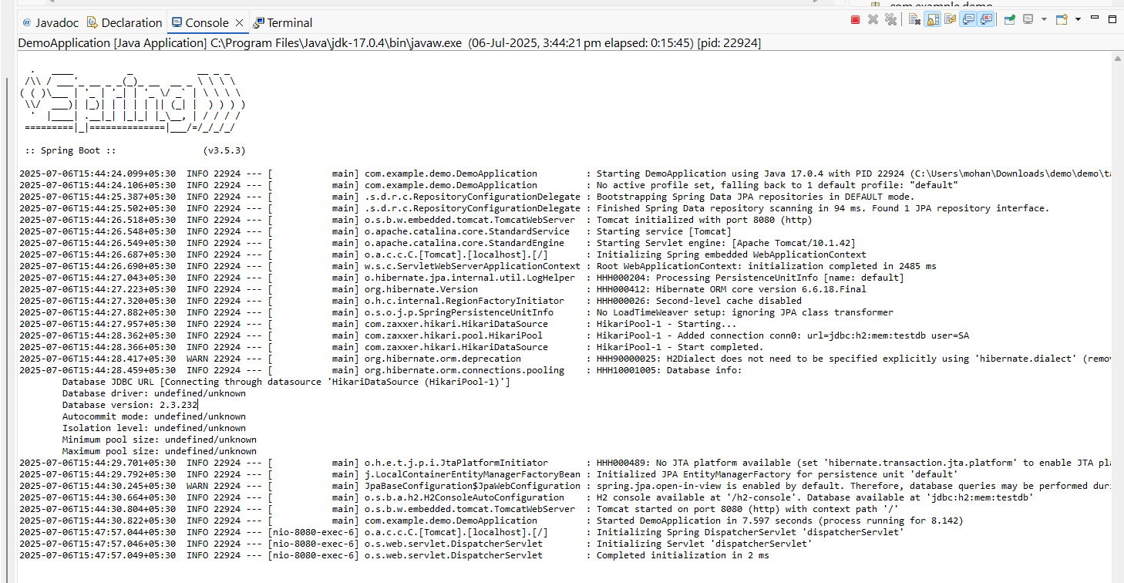

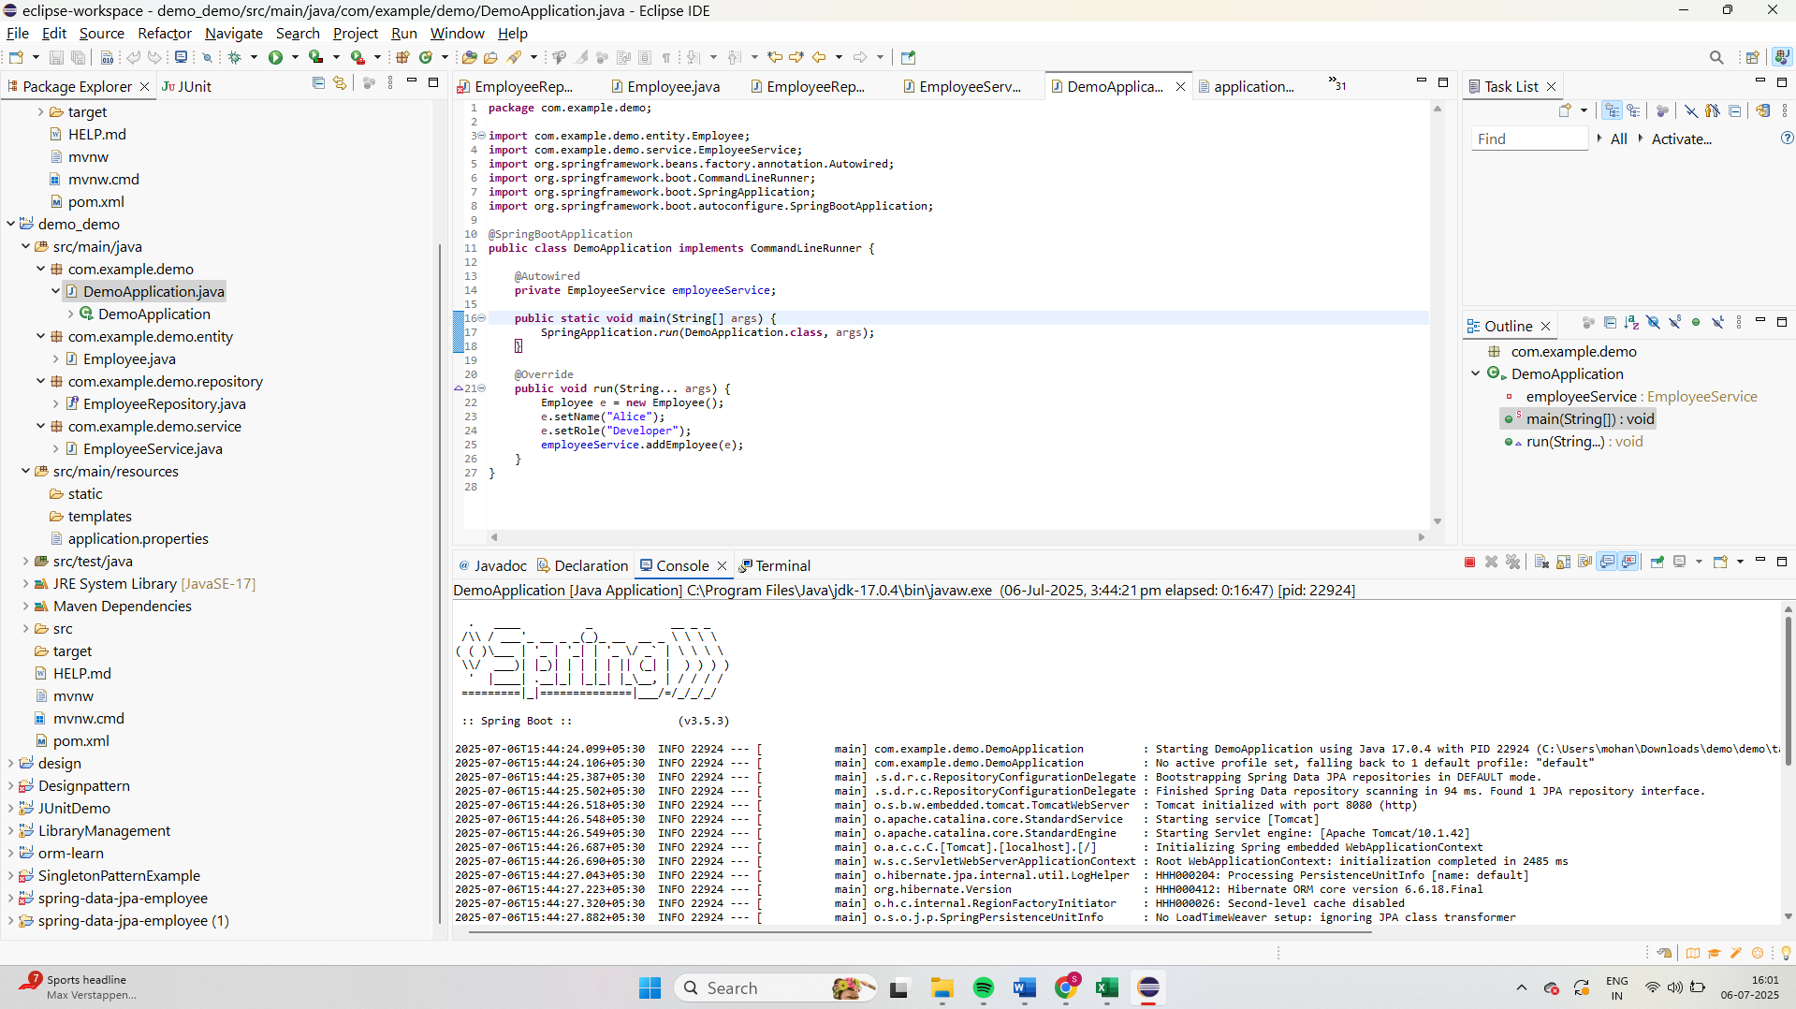

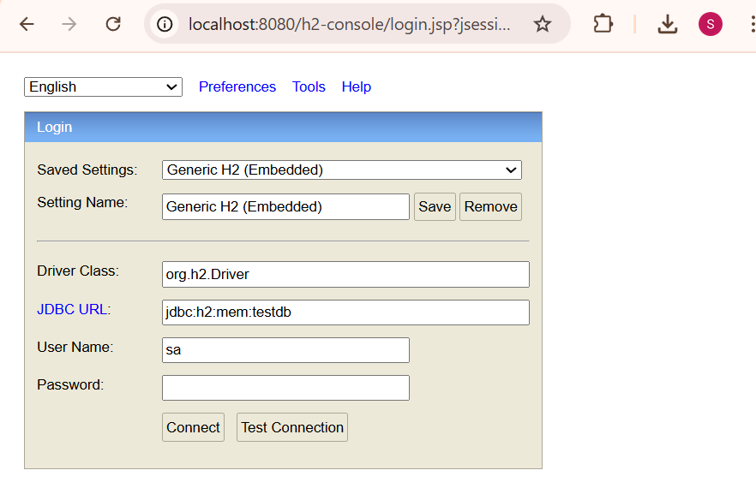

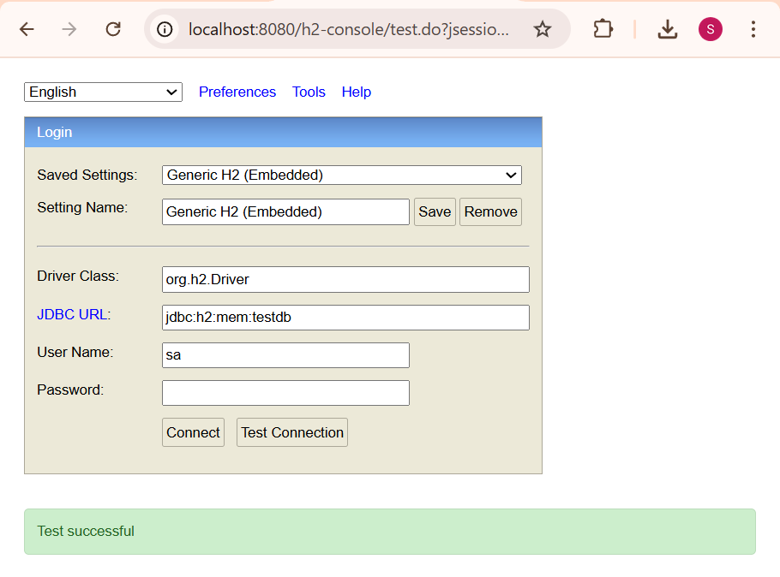

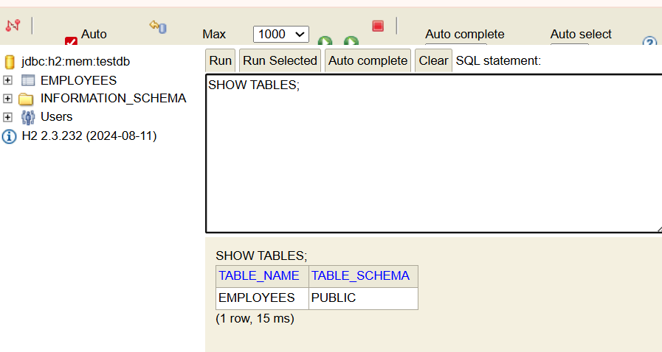

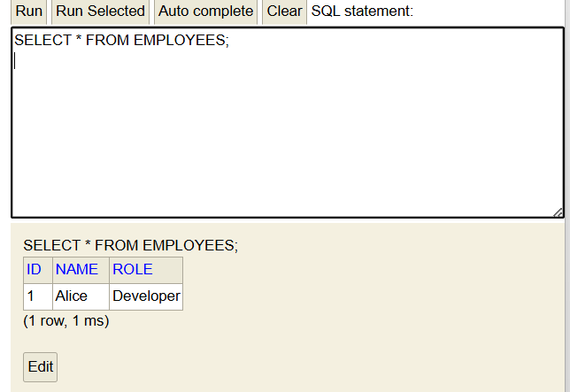

| **Feature** | **Spring Data JPA** | **Hibernate Only** |
| --- | --- | --- |
| **Setup Effort** | **Minimal (auto-config)** | **High (manual config)** |
| **Code Length** | **Very Short** | **Long (session, transaction, etc.)** |
| **Transaction Handling** | **Automatic (@Transactional)** | **Manual** |
| **Repository Layer** | **Auto-generated** | **Must write manually** |
| **Best for** | **Enterprise Spring apps** | **Fine-grained ORM control** |